LISE estimates for 84Zn setting

Using from DALI2 Spring 2015 campaign webpage. Take first setting with expected lower Z and higher energy of beam (largest range): LISE++ for the 85Ga BigRIPS setting : B1_U_BefissionZDSLAA_85Ga_6mmF1.lpp
Setup after last MUSIC: 180cm Air + Al degrader+ MACi (7mm plastic@45 degrees) + AIDA (3mm silicon) + thick Al plate (1 cm).
Energy distribution at middle of H target (i.e. after 350 mg/cm2). Use 216 MeV/u as mean energy for reaction (v= 17.5075 cm/ns). With this choice of initial energy, the Brho of D8 is 5.522 Tm (171.9 MeV/u for 84Zn). The value of Brho(D8) is 5.5351 Tm (172.7 MeV/u) in original LISE file from main experiment: close enough, although I don’t know how that was calculated as behind a faraday cup.
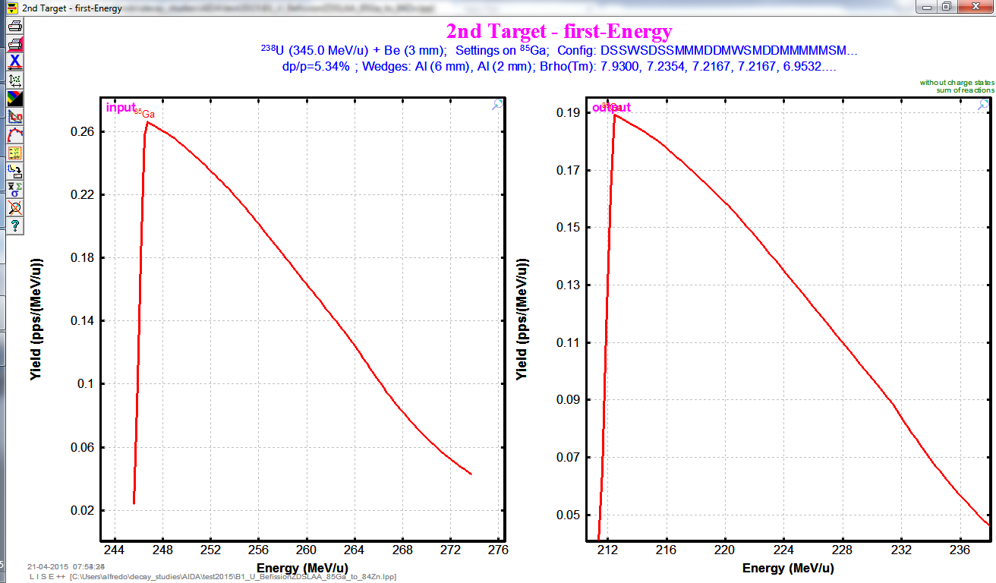
PID of all things that would also come with the beam before reaction target (85Ga->84Zn a weak channel)
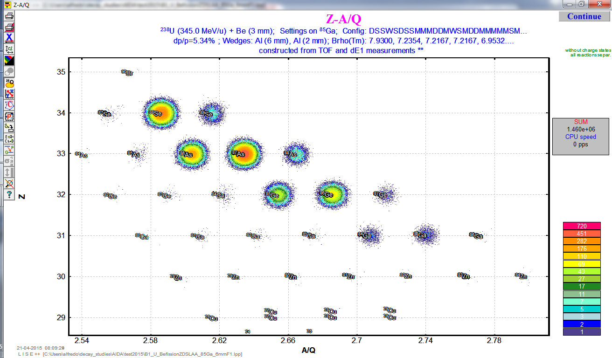
Calculate transmission of 84Zn produced in middle of H target (total target thickness 700 mg/cm2) with initial energy 216 MeV/u (same as 85Ga). The Brho of the last dipole for this setting is Brho(D8)= 5.5220 Tm.
Energy remaining for 84Zn before degrader position is about 152 MeV/u:
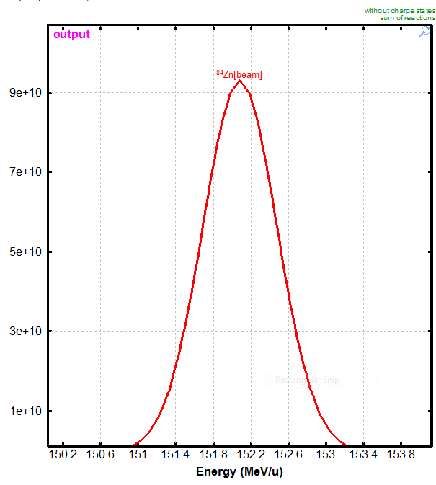
With no Al degrader, 84Zn ions almost make it through the whole DSSD stack (the range in Si for 81 MeV/u 84Zn ions is 2.96 mm):
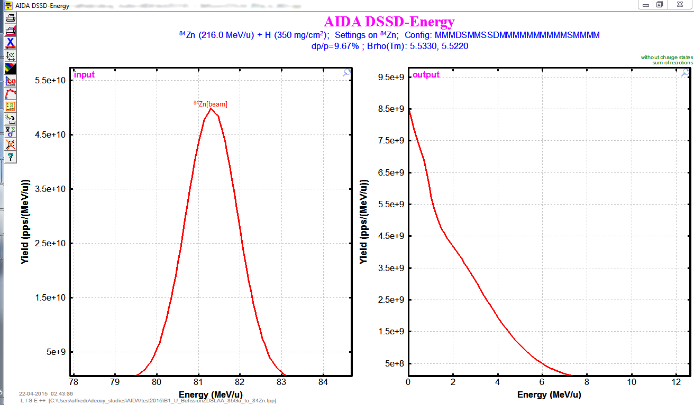
With an Al degrader of 1mm, we would implant 84Zn between the second and third DSSD (of initial energy of 216 MeV/u, though there is likely a broad energy distribution after secondary target). The range in Si for 84Zn at 61 MeV/u is 1.8 mm:
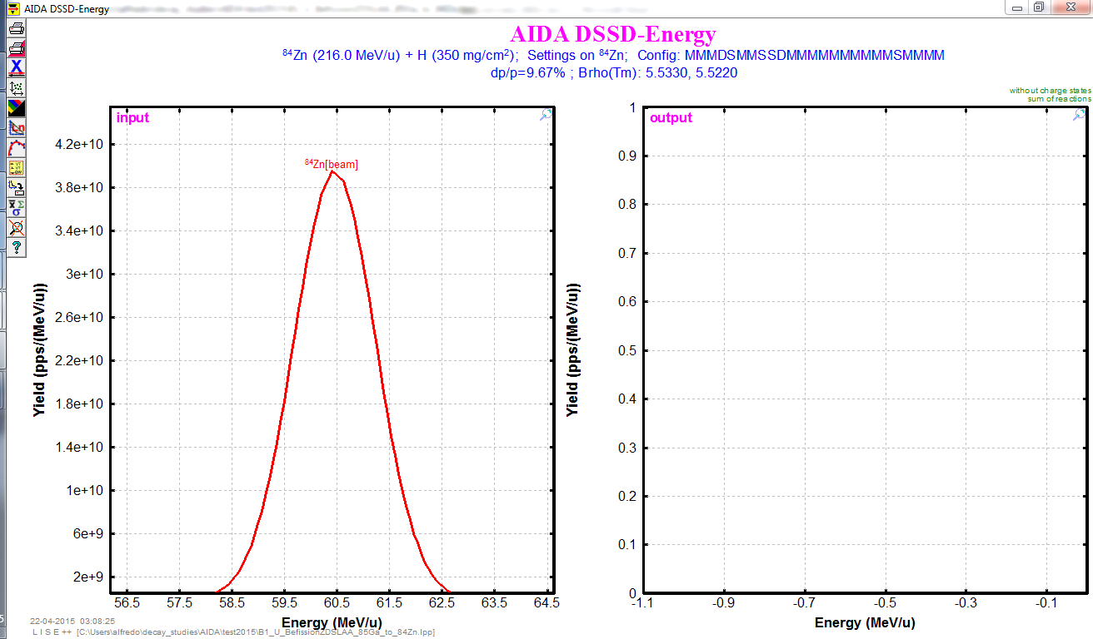

Consider also one of the intense isotopes in the beam, also for a proton knockout channel 87As->86Ge. The energy of 87As in middle of target is about 228 MeV/u.
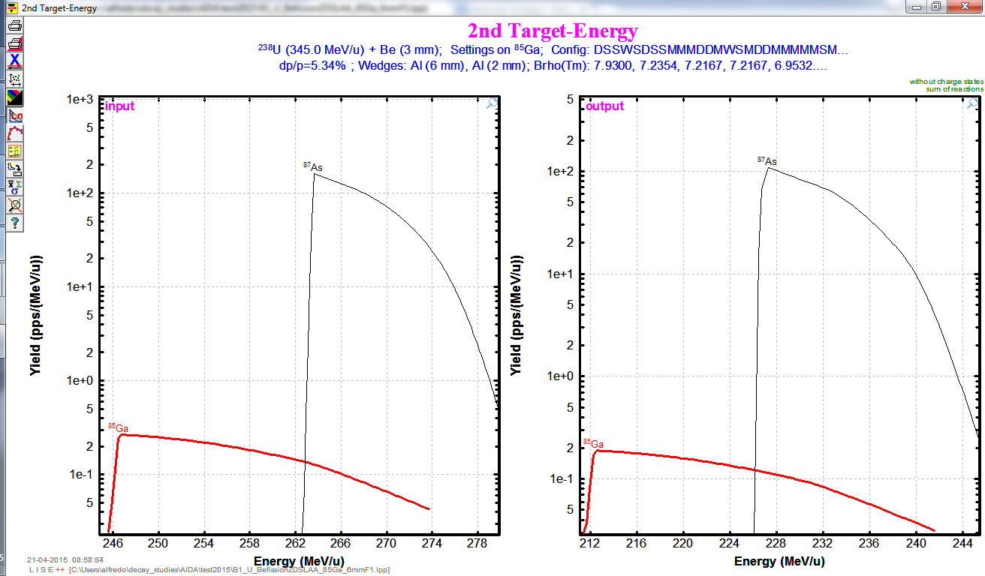
It results in almost same energy in front of DSSD stack, 59.5 MeV/u, so a similar range of 1.6 mm that will also implant the activity between second and third DSSD (higher beam energy in middle of target compensates higher energy loss??):
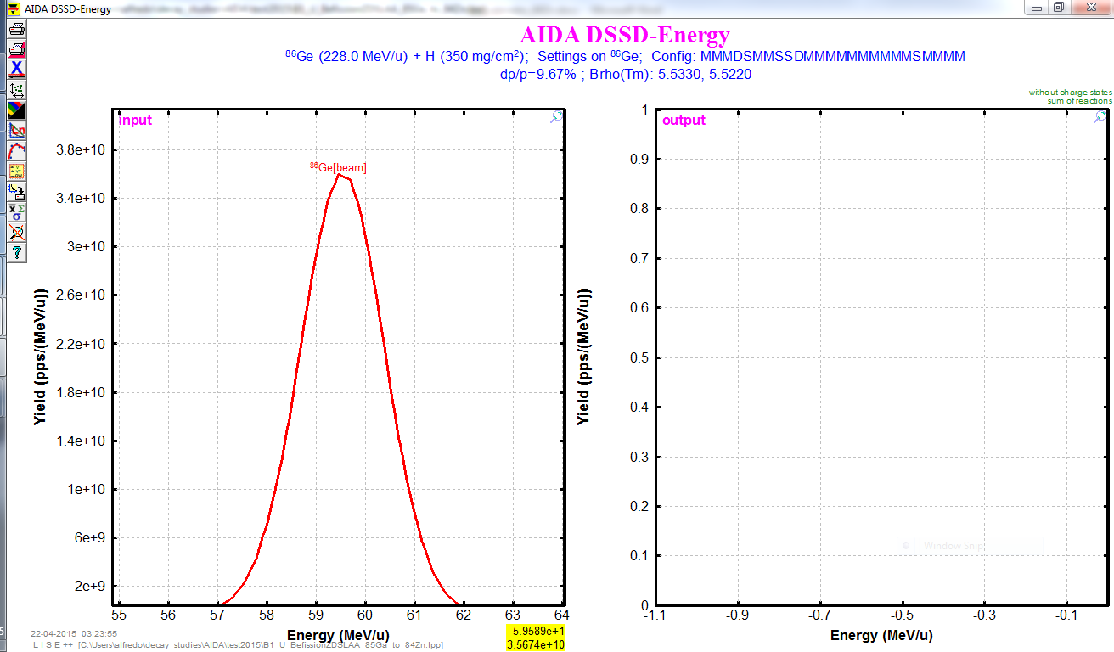

Quick conclusion
Al degrader of 1 mm required in front of implantation setup to stop 84Zn activity in AIDA (end of stack). The range in Si is reduced by ~1.1 mm per each mm of Al added in degrader.
Activity from heavier (more intense) isotopes seems to be implanted at similar location as more exotic isotopes (always considering 1p knockout channel, might be worth looking also at unreacted channels).

