LISE estimates for 84Zn setting

Using from DALI2 Spring 2015 campaign webpage. This is setting with highest expected Z and lower beam energy (thus, shortest range): LISE++ for the 95Br BigRIPS setting : B1_U_BefissionZDSLAA_95Br_6mmF1.lpp
Setup after last MUSIC: 180cm Air + Al degrader+ MACi (7mm plastic@45 degrees) + AIDA (3mm silicon) + thick Al plate (1 cm).
Energy distribution at middle of H target (i.e. after 350 mg/cm2). Use 201 MeV/u as mean energy for reaction, and also energy of 94Se fragments after reaction in middle of target (assume same velocity). With this choice of initial energy, the Brho of D8 is 5.0062 Tm (146.8 MeV/u for 94Se). The value of Brho(D8) is 5.1342 Tm (153.8 MeV/u) in original LISE file from main experiment (not a small difference).
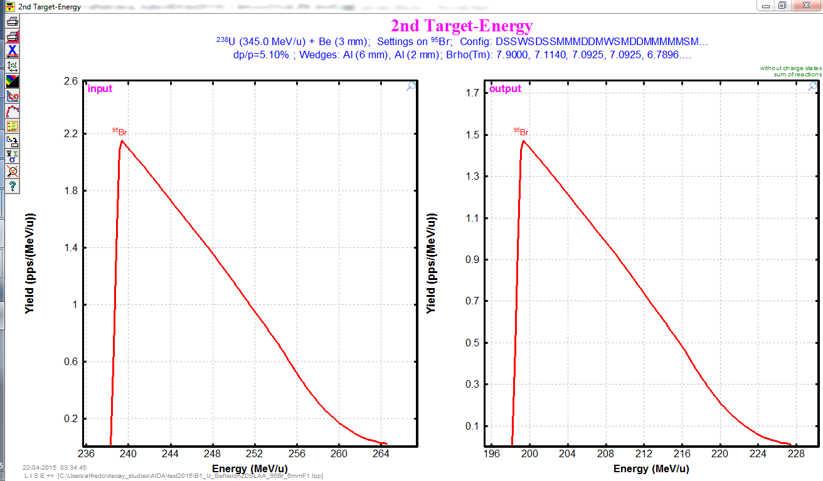
PID of all things that would also come with the beam before reaction target:
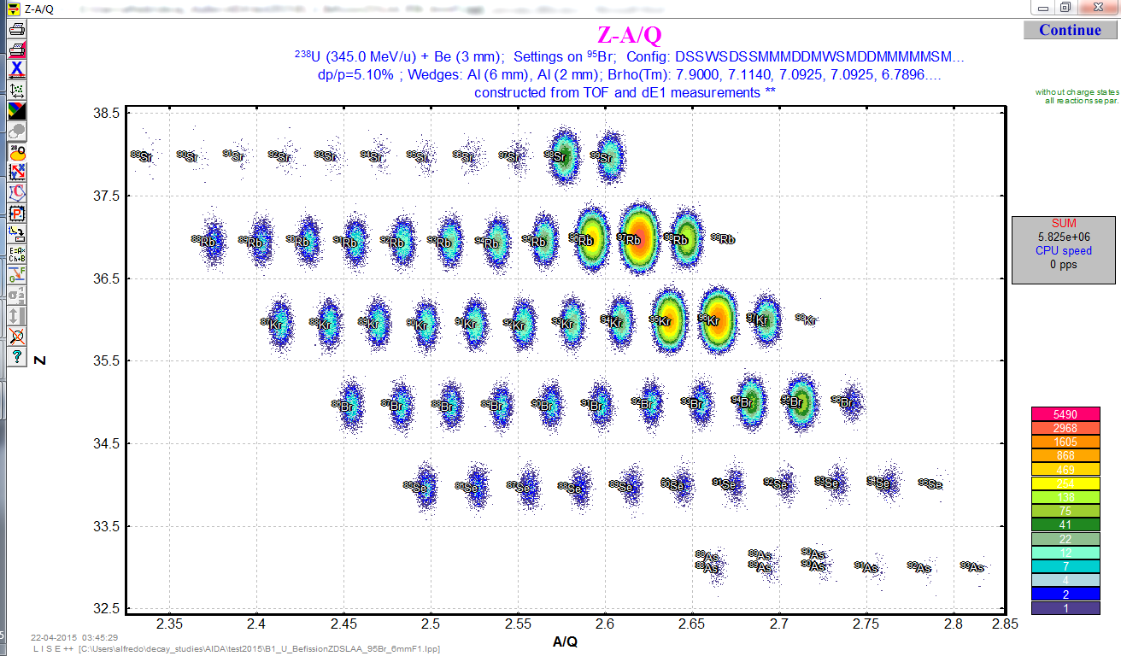
Calculate transmission of 94Se produced in middle of H target (total target thickness 700 mg/cm2) with initial energy 201 MeV/u (same as 95Br). The Brho of the last dipole for this setting is Brho(D8)= 5.0062 Tm.
Energy remaining for 94Se before degrader position is about 121 MeV/u:
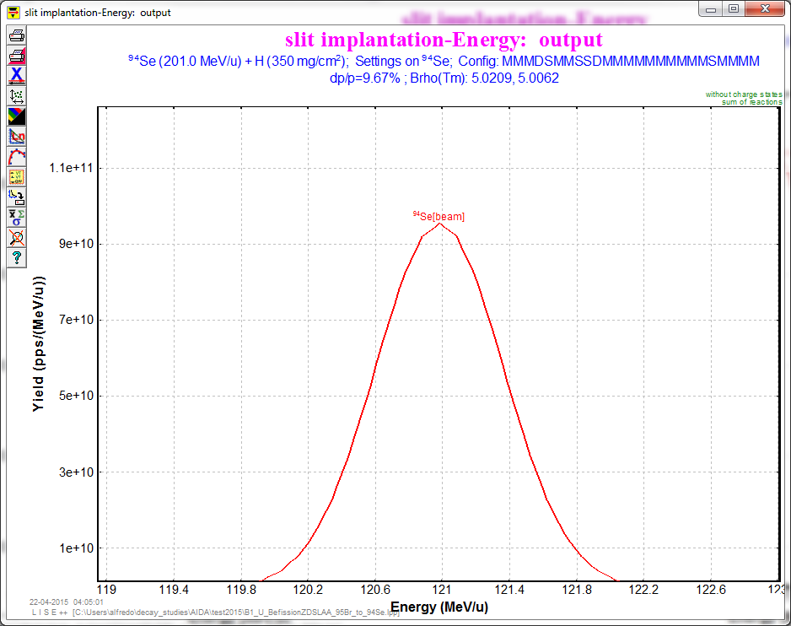
With no Al degrader, all 94Se would already be stopped in the MACi plastic scintillator! The range of 121 MeV/u 94Se in plastic is 9.1 mm (6.5 mm at 45 degrees, so almost pass through):
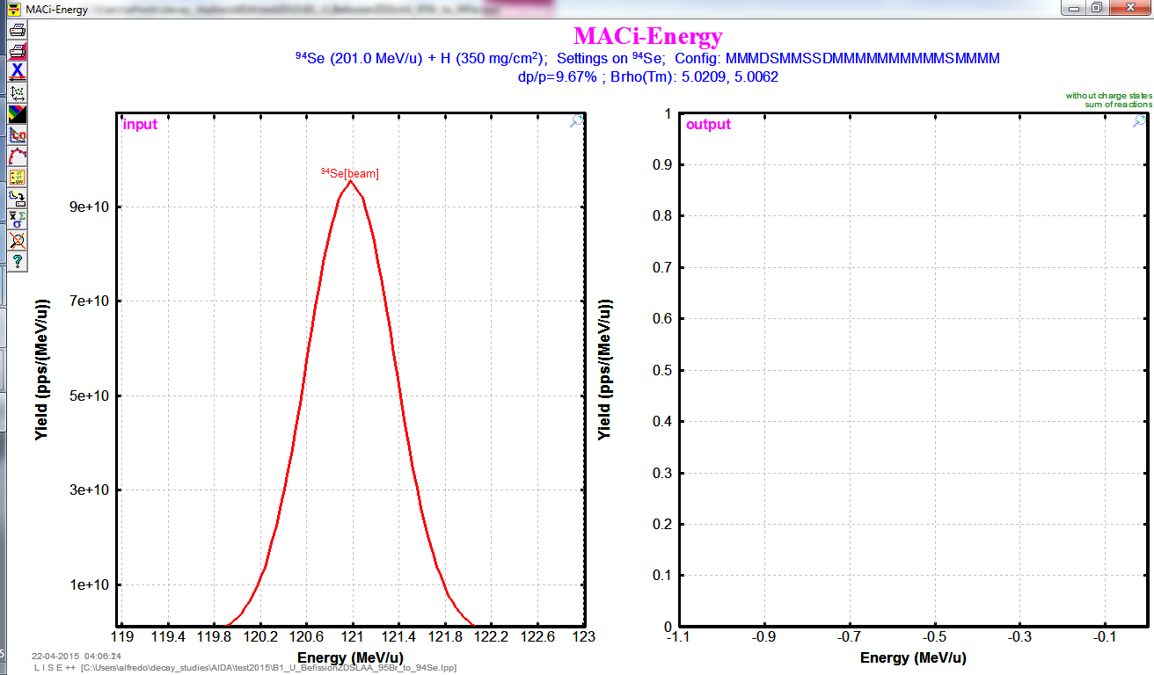

Consider also one intense isotope in the beam, and a proton knockout channel 97Rb->96Kr. The energy of 97Rb in middle of target is about 212 MeV/u:
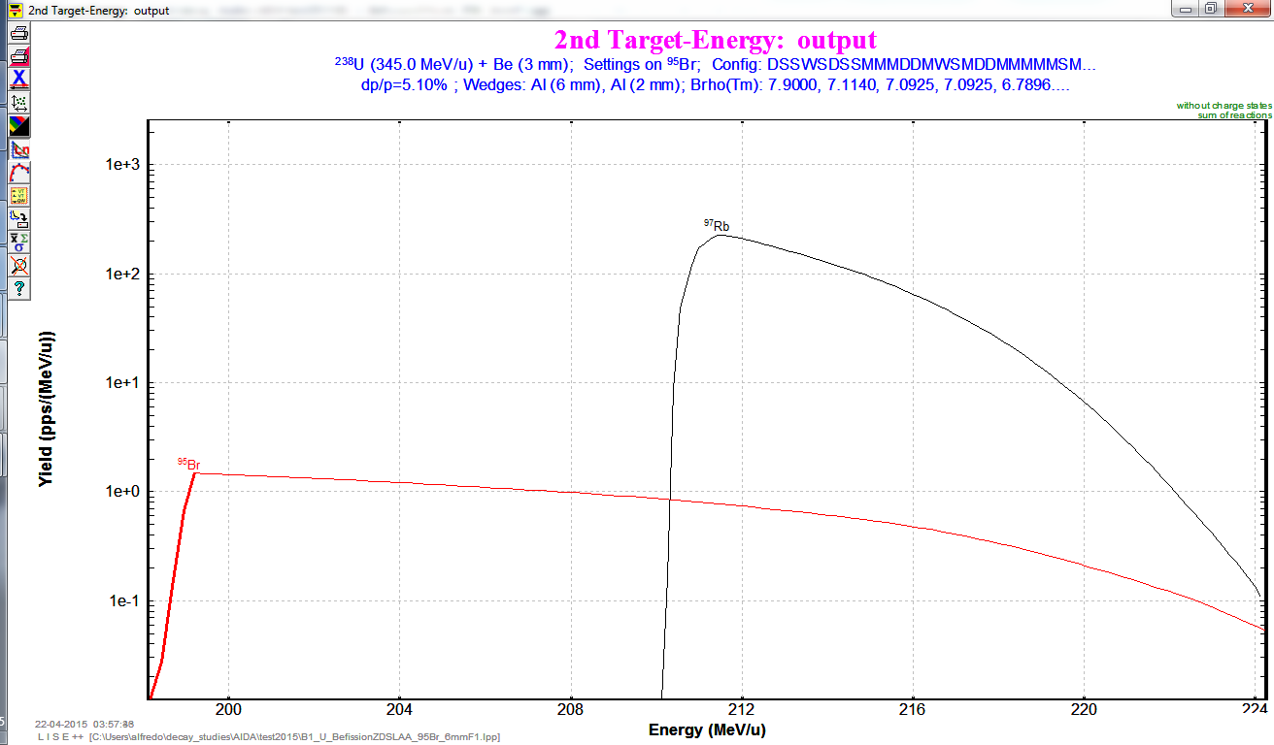
It results is similar to 94Se case, with a energy in front of MACi plastic of 127 MeV/u that is not large enough to reach the AIDA DSSD (range is 9.1 mm in plastic).
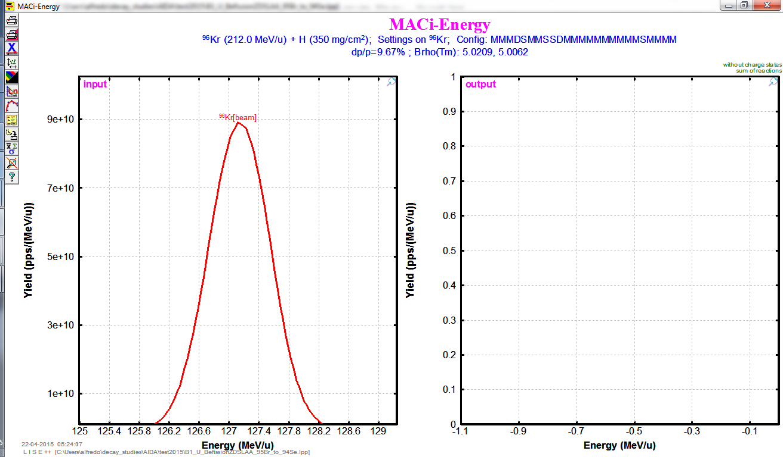

An option if the beam does not make it through the MACi is to remove half of the detector or separate the two halves (apparently it is split horizontally in the middle). Consider that the 1mm veto is still there (i.e. reduce MACi from 7mm@45 deg to 1mm@45 deg). Then, for a 3 mm Al degrader the energy of 94Se before AIDA is 41.5 MeV/u and range in silicon is 0.91 mm (implant between 1st and 2nd DSSD). For 2 mm Al degrader, energy before stack is 69 MeV/u and the range 2.05 mm (implant between 2nd and 3rd DSSD):
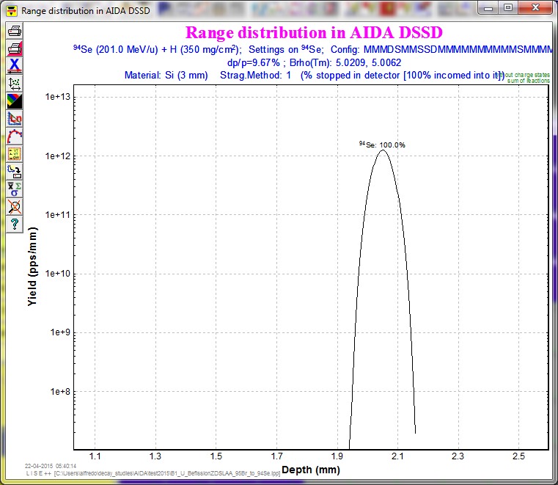

Quick conclusion
Need to remove MACi, or no ions would be implanted in AIDA... unless the tail of energy distribution is large enough.
If we remove the plastic, we would need 2 to 3 mm of Al degrader to implant in a DSSD of AIDA (assuming the 1mm veto after segmented MACi plastics remain).

