7Be(p,p) at CIRCE: 2017/07/10 – 2017/07/22 Update

Thomas Chillery

**What was achieved:**

**2017/07/10 – 2017/07/14**

* The three large crates sent to CIRCE in May 2017 were unpacked and their contents crosschecked with records. Everything arrived!
* The NIM bin, Preamplifier Power Supply, RAL Amplifier Crate, 2 Converter Boxes, and CAMAC Crate were mounted into a rack. All powered on with no problem
* A wooden black box was modified ready for tests of the S2 detectors in atmosphere
* Preamplifers 1 and 2 tested. Preamplifier 1 showed 2 dead channels; negative channels 7 and 15. Preamplifier 2 showed no problems.
* All 16 RAL amplifiers tested. All channels working.
* Preamplifier Cable 3 showed dead channel 0.
* The silicon detector: S2 2323-18 496um was mounted into the black box with 137Cs-enriched water acting as a beta source. A low signal rate was observed: ~ 1 signal per 30 s seen on Friday 14th.

The beta source was expected to be ~100 Bq, Geiger counters measured ~14 cps

* 500 ml of 137Cs enriched water was heated to 70 celsius over the weekend

**2017/07/17 – 2017/07/22**

* On Monday 17th ~ 100 ml of the 137Cs-enriched water remained, ~25 ml of this was placed into the black box with S2 2323-18. It had expected activity ~ 125 Bq.
* No signals observed, Geiger counter measured ~14 cps.
* A NaI(Tl) scintillator measured both this new source and the source used on Friday 14th. Only background was observed with no clear 137Cs peak in either spectrum
* After spending Monday working on this beta-source problem my focus was diverted to setting up the target chamber
* Tuesday 18th – Thursday 20th was dedicated to mounting parts onto the target chamber. This included the collar, three lids, vacuum feedthroughs, the target ladder with its two Al boxes, the diode detector with its mount, and the two irises
* 6 targets were mounted on the ladder, 4 were 930 ug/cm2 CH2, targets 1->4 and the other 2 were 100 ug/cm2 and 50 ug/cm2 natC
* The targets were optically aligned with the beam axis using a telescope, this proved difficult because a metal T-piece used to correctly mount the target ladder to the actuator was missing.
* Plastic tracking material CR 117 was mounted onto both irises, allowing the beam intensity at the S2 positions to be determined.
* Unfortunately, a hole was not cut in the plastic, thus beam could not pass through to be focused on a faraday cup downstream from the chamber. Instead the beam was focused using a faraday cup upstream from the chamber
* The silicon diode was mounted at ~28.8 degrees with respect to the lid. This corresponds to ~61.2 degrees between the target center and the diode detector
* 7Li of 7 MeV (lab) was fired at CH2 target 3. On Thursday 20th no backscattered beam was observed in the diode. The chamber was vented for the night
* Friday 21st the two irises were dismounted and a ~11mm hole cut in the center. This was not perfectly circular but allowed enough room for beam to pass. During this procedure the downstream plastic was damaged beyond repair and a new sheet was mounted.
* The 1mm collimator in front of the diode detector was removed in case the angle of the diode was slightly off. This is a possibility – setting the diode angle is not trivial
* Firing beam no peaks were observed. The Ortec 571 amplifier had an incorrect input polarity setting, its setting was changed from POS to NEG. A peak appeared in the diode spectrum!
* Due to limited beamtime the only data collected was a 5 minute spectrum for 7Li with 7MeV (lab) on CH2 target 3. This was saved in 20170721_7Bepp/Target3.hist.
* This spectrum was not calibrated. On Monday 24th Lucio will mount an alpha source on the target holder and collect a calibration spectrum.
* The chamber vacuum was very poor – 1.5e-2 mBar. Leak tests were performed after the measurement. The lid -> collar section was extremely leaky. It was suggested that thicker O-rings and bolts to replace the threaded rod should be obtained.
* The CR 117 plastic was not analysed this week. This should be measured next week.
* On Saturday 22nd I packed away everything not needed for the calibration. The target holder, central lid, diode mount, diode detector, and targets were left in the ERNA room ready for Mondays calibration. The collar, and upstream and downstream lids were left mounted on the target chamber.

**Problems Ongoing:**

1. S2 Silicon detectors don’t fit in the target chamber

Suggested solution/s:

* Contact Micron Semiconductor Ltd and inquire into removing 2mm off both sides of the S2 detectors. Time required: unknown
* Dismount the three sections of the target chamber and send them to Naples workshop. Remove 1mm off both inner walls. Return to CIRCE for remounting. Time required: ~1 month.

Action taken so far: I contacted Micron on 20/07/2017, no reply received at time of writing

1. Downstream preamplifier box does not fit on top of target chamber – it collides with the downstream turbo

Suggested solution/s:

* This turbo will be raised soon, then I can reattempt to mount the preamplifier box.
* If the box still does not fit, we can remove the turbo

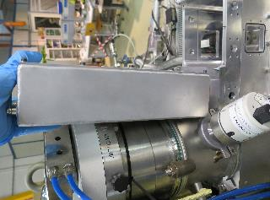 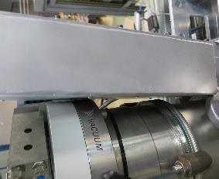

Downstream Preamp Box

1. Large leak present in target chamber

Leak testing on 21/07/2017 showed the leak was present at the seal between the lids and collar on the target chamber

Suggested solution/s:

* The O-rings are 2.5mm thick, whereas the grooves in the collar are 3mm thick. Therefore we will order thicker O-rings
* The 70mm threaded rods used to attach the lids -> collar -> beam chamber should be replaced with bolts M4X70 (minimum quantity 12 – order 20 for spare)

1. For reproducible beam alignment we need a blank target holder with a 3mm hole (as opposed to the 10mm hole in the targets)

This would allow us to know that the beam will focus onto the target with small uncertainty.

1. Target ladder is missing a T-piece to ensure the ladder and targets are perpendicular to the beam axis

Suggested solution:

* I have the CAD drawing from Peter, I will request Antonio to manufacture this piece in CIRCE

1. In the present configuration, the target ladder does not retract enough to allow the final three mounted targets to align with the beam.

Mounting the target ladder on an additional Al tube allowed these three targets to align with the beam.

However, in the modified configuration the target holder cannot extend far enough for the first two targets to align with the beam.

Suggested solution:

* An extension should be made for the Al box located opposite the target ladder, thus allowing enough space for the ladder to move when mounted in the original configuration (with no Al tube). This extension would need to be ~60mm long.

1. The Al box used to mount the target ladder has a hole in its centre. We currently do not have a metal ring with the correct diameter of this hole. The current ring used has too small a diameter

Solution: Obtain the correct sized metal ring thus ensuring the ladder will be centred in the chamber. This diameter should be measured after calibration on Monday 24th

1. Both Al boxes used for the target ladder are too wide, causing them to collide with the bolts mounting the beam chamber to the pumping chamber. Currently the washers used by these three bolts have been removed to allow space. This is not ideal for vacuum and alignment purposes.

Solution:

* 2mm should be removed from both sides of the actuator Al box
* 1mm should be removed from both sides of the spacer Al box

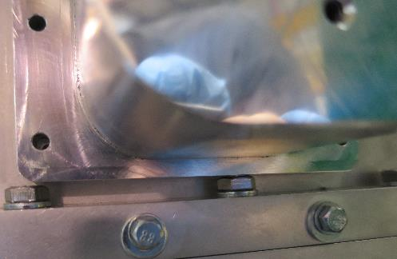 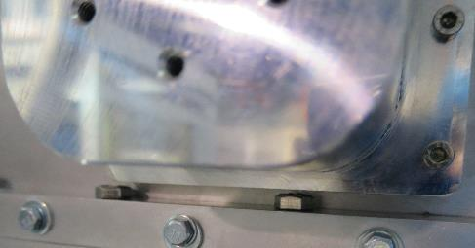

Al actuator box before (left) and after (right) removing the beam chamber washers

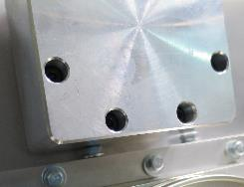 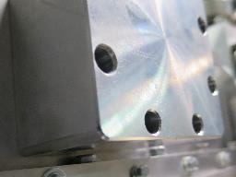

Al spacer box before (left) and after (right) removing the beam chambers washers

1. The current lemo cable between the diode detector PCB and vacuum feedthrough is too long – 17cm. This was the shortest found in CIRCE.

Solution: We need to make a 5cm long lemo-lemo cable

1. The current electronics rack would benefit from wheels for easier access and faster setup

**Additional Comments:**

* Creating an online eLog would make collaboration between Edinburgh and Caserta simpler than reliance on emails. This would also make expanding the collaboration straightforward
* Liz and I may likely appear in a documentary!

It’s about the 14C measurements performed at CIRCE on a portrait thought to be of Leonardo Davinci – we were extras filmed turning a dial on a NIM bin and randomly writing in a log book.